Highlights of the Life and Work of Edith Gault

(“HORTENSE”)

The following is a piece of (Methodist) Church history which has been a pleasure to put together firstly due to the subject matter, and secondly due to the link with our Church. I hope you find it an interesting read.

A Little Background

“The Spectator and Methodist Chronicle” was a journal/magazine which was published on a weekly basis from April 27, 1875 until August 1953. In September 1953 it was renamed “The Spectator,” and continued to run as a Methodist weekly (covering the Methodist Conference of Victoria and Tasmania), until May 1971.

The magazine in the 1920’s & 30’s and beyond was a good reflection of Australian, and Australian Religious society at the time. It was divided into several discrete sections – all the big theological issues were discussed up front, and speeches and profiles etc., by prominent church people were featured. Most of these, unsurprisingly, were by, and about, church men.

Towards the back couple of pages of the magazine were the Overseas Mission reports, the weekly serial story, and the Women and Children’s pages. From 1922 until September 1926, The Spectator had a Section entitled the “Women’s Corner”, which was authored by a “Sister Faith.”

Sister Faith began each of her weekly columns with the somewhat confronting opening address of “Dear Comrade Women…..,” which today might suggest something different to perhaps what was intended back in those times.

In the magazine edition of September 29, 1926, there were two articles on “The Passing of Sister Faith” – it seems that she was suddenly taken ill on Friday, 17 September, she never regained consciousness, and passed away at Epworth Hospital on Wednesday 22 September.

The Arrival of “HORTENSE”

In the following edition of ‘The Spectator’, dated October 6, 1926, the Women’s Corner opened with the somewhat more warm and welcoming new address “My Dear Friends..…”, and what followed was a personal tribute to Sister Faith, signed off for the first time by her replacement, “HORTENSE”.

The tribute read, in part, as follows:

“Our friend who has been counsellor and comforter to so many has left us…….Sister Faith belonged to the League of Brave Things – that League whose entrance is pain and whose subscriptions are paid automatically by disabilities and limitations.

The League has never had a braver member. Such a small, frail body – such a fearless, valiant soul! The only thing she feared was lest she might fall behind in her share of the world’s work…..

Her departure has left us poorer. So we say. But need that be so? No memories to her name could be better and finer than for those whom she has helped in diverse ways to answer their own prayers……. , and to resolve that…. they will try to fill the gap which her departure has left.

Your friend,
HORTENSE.”

It was quite a personal and moving opening to a literary career – “Hortense’s” talent was on display for all to see from Day One. All subsequent weekly ‘talks’ after that date opened with the welcoming “My Dear Friends..…”, and were signed off by “Your Friend, HORTENSE.”

So, who was “HORTENSE?”

This time, the identity of Hortense was revealed, thankfully, well before her death.

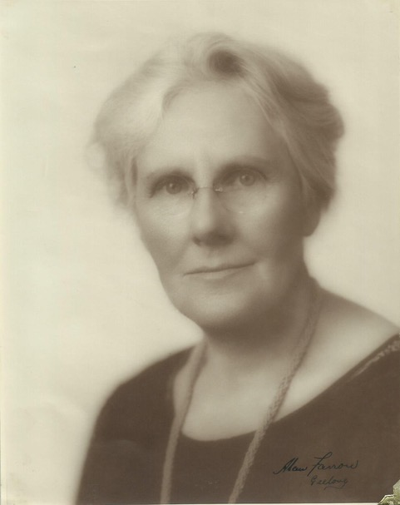

“HORTENSE” turned out to be the pseudonym of Edith Gault, wife of Padre James Gault, whose life and work is commemorated in one of the stained glass windows at our Church.

A photo of Edith Gault, taken in her 60’s, in her prime of writing (photo provided courtesy of Anne Gibbs, her grand-daughter)

Edith Anna Maria Raston was born in Warrnambool in 1865. In 1900, in Mornington, she married James Gault.

Edith’s family have told me that she was an extremely well educated woman for her time, (and this shows up in her writing time and time again), and they understand she had a music degree from the Conservatorium in Adelaide.

Edith also taught herself Greek, as she was interested to read the Bible in an earlier version than King James!

Until relatively recently, there were very few opportunities for women to achieve any sort of formal profile in the church hierarchy. However, Edith Gault was one woman who was able to forge an identity for herself, and this article hopes to go some way in acknowledging her unique contribution.

”Everyday Talks” by HORTENSE

‘Hortense’ started writing her weekly column in October 1926.

Clearly, the thoughts and words of Edith Gault struck a chord in her readership, for in the 4 November, 1931 edition of The Spectator, in a list of “Items of Interest”, appeared the following:
“Mrs J. A. Gault, who writes in our columns under the title of Hortense, is publishing a most attractive little volume entitled “Everyday Talks.” Twelve studies in the usual attractive format for Hortense are supplied, and the booklet would make a very attractive Christmas gift. It will be obtainable at the Book Depot and at the “Spectator” Office. Price1/-, posted, 1/1.”

This advertisement was repeated twice during December 1931, as the volume had been such a success, the first edition had sold out.

”More Everyday Talks”, and Further Success

Hortense’s popularity continued to grow, and in the edition of October 18, 1933, appeared the following notification:
Following the Gault family’s visit to Camberwell Uniting Church earlier in 2017, Edith’s great granddaughter, Louisa Gibbs mentioned that the family had a copy this booklet.

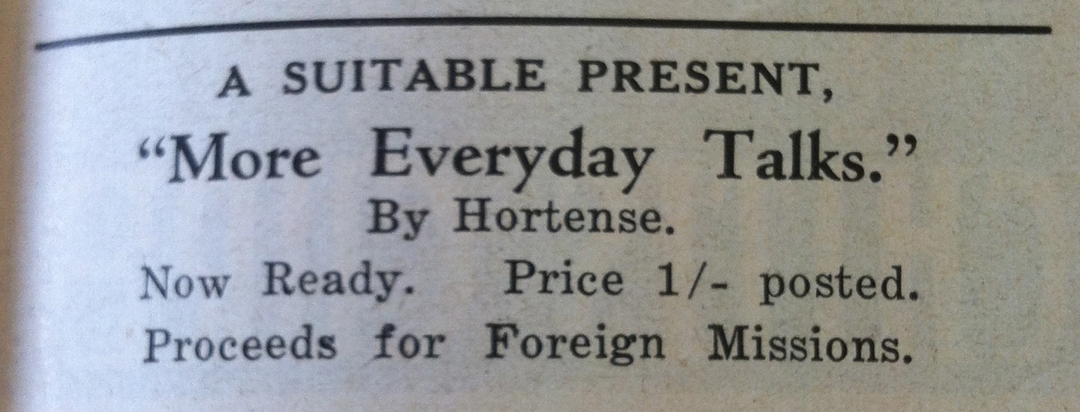

Louisa’s mother Anne subsequently kindly loaned the Church a copy of the booklet in the hope that we might be able to find out when the booklet might have been published, and the dates of when the original individual “Talks” were first published.

A Family Treasure

In the booklet, each of her “Talks” in the booklet is given a title and a chapter to itself.

Her columns in The Spectator had no heading, as they were intended as weekly chats between Hortense and her audience.

Subsequent research however confirmed that ten (10) of the thirteen (13) articles in the booklet were written during 1932. The remaining three were taken from Talks given in July and August 1933. So October 1933 is the most likely date of publication of this booklet.

This volume also has a watercolour on the front cover, but there is no reference as to the artist. I would not be surprised if it were the author.

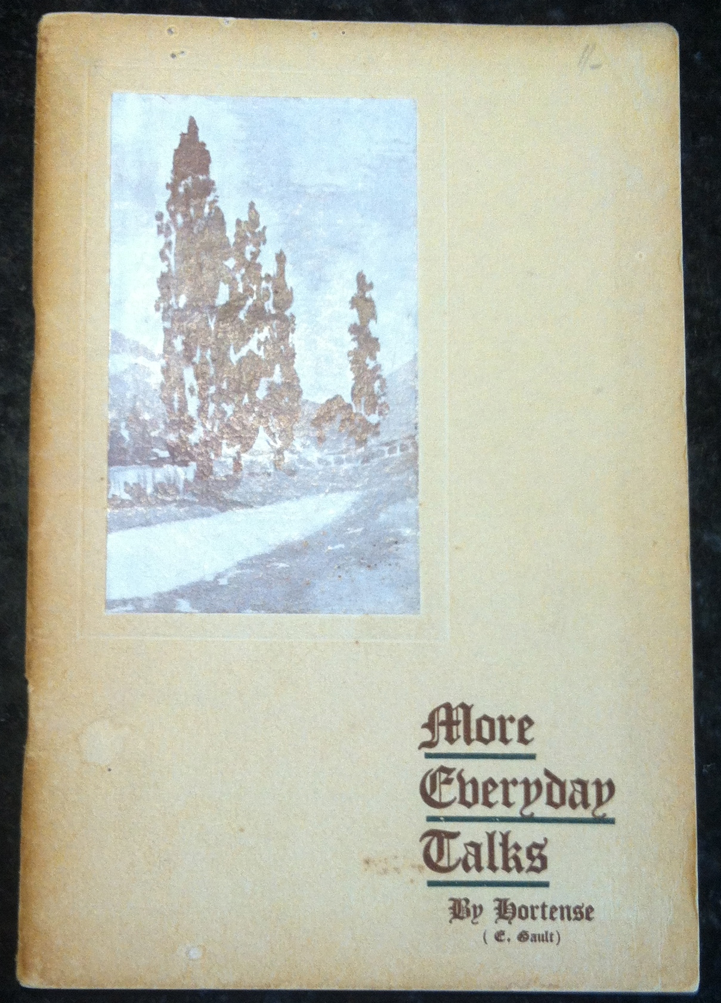

Life goes on…..but with hiccups in 1935 and 1938

Weekly columns, penned by Hortense, continued uninterrupted from October 1926 until 1935, when she had a short break to care for her ill husband.

The Padre recovered temporarily, however on February 2, 1938 it was reported that “the Rev. J. A. Gault, a Methodist minister, who was widely known to Australian soldiers as Padre Gault (Captain Chaplain 4th Class), died on February 2, 1938, after a long illness, aged 72 years.” His last charge was at Camberwell (1932 – 34).

In The Spectator of February 9, was the following notice:

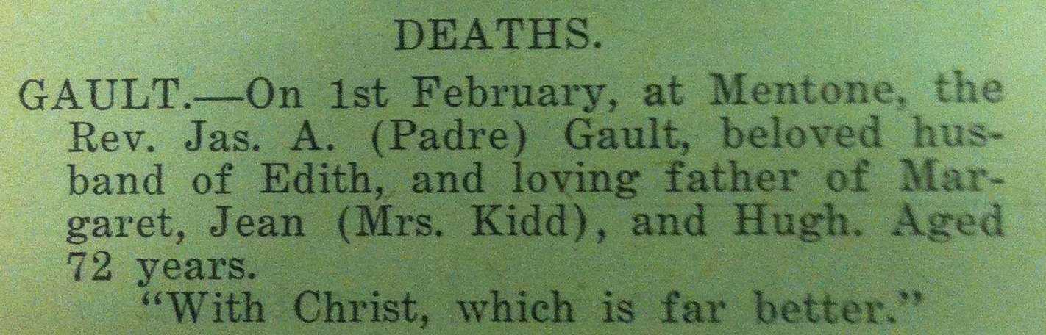

It is an interesting quote at the conclusion of the Notice. It comes from the Letter of St Paul to the Philippians 1:23 – “For I am in a strait betwixt two, having a desire to depart (this life), and to be with Christ; which is far better.” The full context (in a more modern biblical text) can be found on page 188 of the Bibles in the pews.

February 23, 1939

In this edition, “Hortense” showed the strength of her faith at her time of loss:

“It is when we are face to face with what – for want of a better name – we call death, that we find what a sharp dividing line there is between faith and sight.

In other circumstances of life we muddle along with a certain amount of faith; feeling that somehow God will help us through: that probably some door will open at the end of the dark passage: that events may prove to us that God’s hand has been directing us, and will do so again. One never knows!

But in the face of death it is different. To sight it is so overwhelmingly the end. There is no possibility of alteration or change. The dear body we loved will never again respond to our ministry; it is the end.

Analogies suggesting comfort……....do not go very far at such a time. They suggest hope, but we need more than that. Hope, after all, has its feet in mortal soil. Faith is in a different realm. At this time, the word of Christ, “Today shalt thou be with me in Paradise,” is inestimably precious. And that earlier word at the graveside of Lazarus, “I am the resurrection and the Life,” is an abiding spring of living water in what would be otherwise a desert land.

The Faith that realises that Christ died for our sins opens the door to a life of victory and freedom; the faith which realises that Christ has abolished death, opens the door to a life of blessedness for our dear ones……….”

Edith’s inner strength, and the preciousness of her Faith, are all on display here.

April 26, 1939

Weekly columns, penned by Hortense, continued from 1935 until April 26, 1939, despite, or perhaps inspired by, the loss of her husband.

The opening of her April 29 column of 1939 is significant, as she began with a reference to:

“Anzac Day and all the memories it recalls: of pride in the brave spirit of our men as they faced an unknown peril; of grief for those who lost their dearest and best. Some of these have now followed husbands and sons into the spirit world, where they will look on life and its tragedies with different eyes….”

She then went on to say:

“Coming nearer home, is not a garden a continual reminder of Easter – a continuous resurrection which we take for granted, but which baffles our understanding when we give ourselves time to think about it? We plough the field and scatter – in other words, we trench and manure and lime and plant and sow, but it is God Who gives the increase.

Having done our little part, we have to wait until the uninteresting-looking bulb we planted comes up a golden daffodil, or the tiny seeds we sowed a plot of blue larkspur, and so on ad infinitum. If we were not so used to it all, we should be more awake to the marvel of it, and exclaim with reverence, “What hath God wrought!”

In profusion, roses and dahlias and marigolds and salvias, with their crescendo from delicate lavender to purple, and cannas, and I know not what beside, have given, and are giving, lavishly of their beauty…. The reappearance of the perennials, some of which have been out of sight out of mind, is always a delight.

A lemon tree, opposite me as I write on the verandah, and breathing sweetness for the bees as well as for me, has been doing its bit since … it was kindly rescued from death by some workmen altering a room.

Of course, trees mean birds, and apricots are an easy prey and even quinces need watching. They are sweet company all day long…. In a gum tree at the end of the garden, some brown birds have made a home. They are very noisy, but being Australian, I love to hear them. For they give me a vision of sunny uplands and wooded valleys and the light on glistening tree tops. And the happy gurgle of magpies is a fine antidote to the morning paper. The troubles men make will pass, but the gifts of God go on as they have been going on since He planted a garden.

This will probably be the last letter over the signature of “Hortense.” It has been a privilege to write for this “Women’s Corner,” and I have made many friends through its medium. I shall miss the weekly fellowship, but, in my successor, my loss will be your gain.

Your friend, HORTENSE”

And with that, Hortense signed off.

That she commenced her last column with a reference to Anzac Day, a baton which has been picked up by her great grand-daughter, I find a wonderful coincidence.

Why Choose the name ‘Hortense”?

As readers would note from the passage quoted above, Edith Gault wrote many of her weekly columns from her verandah overlooking her garden, and in many of her articles she praised God for the gift of and diversity of nature.

I have since learnt that perhaps the choosing of Edith’s pseudonym may not have been random – Hortense is a French feminine given name that comes from the Latin meaning “gardener.”

A Remarkable Person, a quiet achiever

Under her pseudonym of Hortense, Edith Gault wrote her column each week from October 6 1926 until April 26, 1939– some 10 and a half years.

That equates to over 500 separate weekly pieces of work. They were not insignificant of fluffy space-fillers either, and they served a purpose and acted as a beacon, comfort and support for a wide and committed readership.

That is, I think, a truly remarkable and dedicated achievement, pushing on despite the long illness and ultimate death of her husband. A Christian woman of amazing strength, character, intelligence, compassion, empathy and understanding.

Peace

In The Argus, Friday 23 January 1942, it was reported that:

Mrs Edith Gault who died at her home in Sea Parade, Mentone, on Wednesday, was the widow of Rev James A Gault. Mrs Gault, who was 76, was married 42 years ago.

Ed

_________________________________________

A short postscript

The author of the above selective history extends a huge ‘thankyou’ to Edith’s family for the opportunity to research “Hortense”, and to learn about a remarkable woman, who did not live in her husband’s shadow, but made her own mark in history.

The author did a couple of paper rounds when he was at secondary school to earn pocket money. His first paper round included delivering newspapers to Sea Parade in Mentone. The phrase, “it’s a small world,” continues to follow the story of the Gault family in its links with Camberwell Uniting Church.

* * *

PS. I took the liberty of photocopying the booklet “More Everyday Talks”. Anyone is welcome to read Edith’s observations and commentaries on life.

PPS. Outside of memorabilia retained by family, even with the advent of the internet, information on many ‘ordinary’ individuals can be hard to come by.

Also, many historical church records have not been preserved, as there were just not the resources available to load documents onto modern technology to preserve information or references. Fortunately, this is now happening at the hands of some very dedicated volunteers, including our own Lorraine Sage.

PPPS. A special thank you to the Archivist and the willing helpers at the Uniting Church Archives Office, who have been so welcoming, friendly, and helpful.

* * *

